

**SANYO 0.75 Ton**

**Rs. 158,400/-**

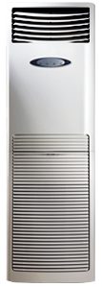

**Product Features**

* High Temperature Stable Running work upto 52C (T3 condition)
* Antifouling and Movable Baffle
* Compact Design
* 3D airflow
* Rounding Natural Air

**Specification**

**Type** Wall Mounted Split AC

**Cooling (Btu/h)** 37000

**Voltage (V)** 220-240

**Power Input (W)** 4500

**EER (Btu/W-h-W/W)** 6.2-1.8